1. Exceptional breakpoint allows you to instruct the debugger to pause the execution on the line (which you don’t know) when an exception specified by you occurs unlike the Line Breakpoints or method breakpoints (In both cases, we have to specifically put a breakpoint manually. Method breakpoint we will see in next lecture).  
   So, you just define exception to the Debugger and say it to pause at the line where that exception occurs.
2. 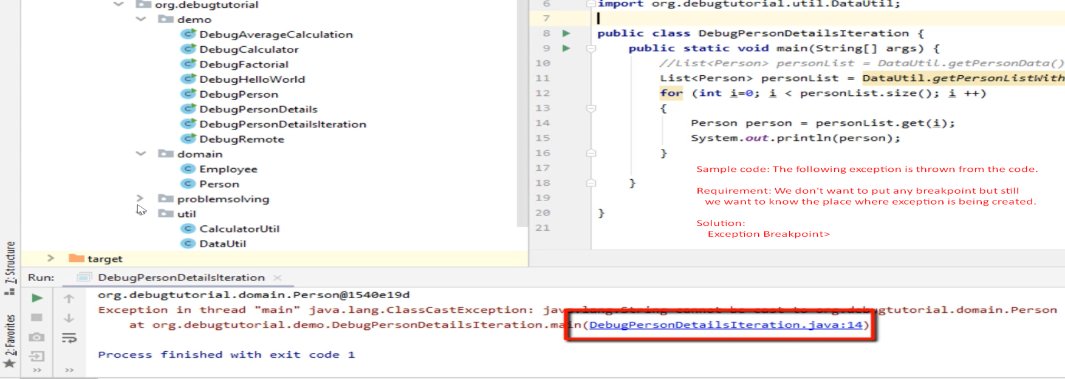
3. How to define exception breakpoint.
4. 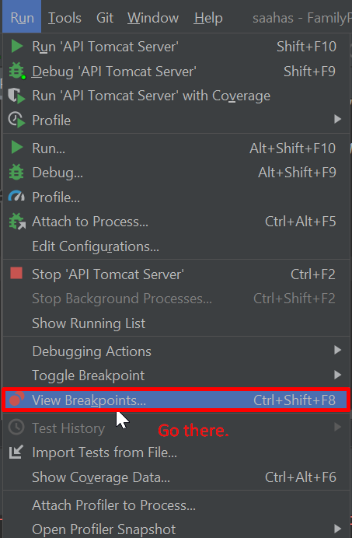
5. 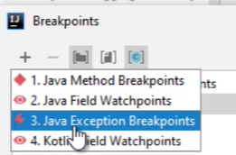
6. 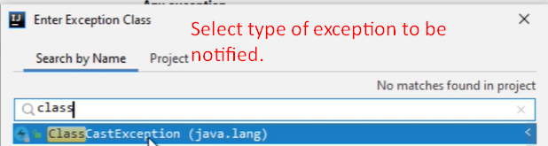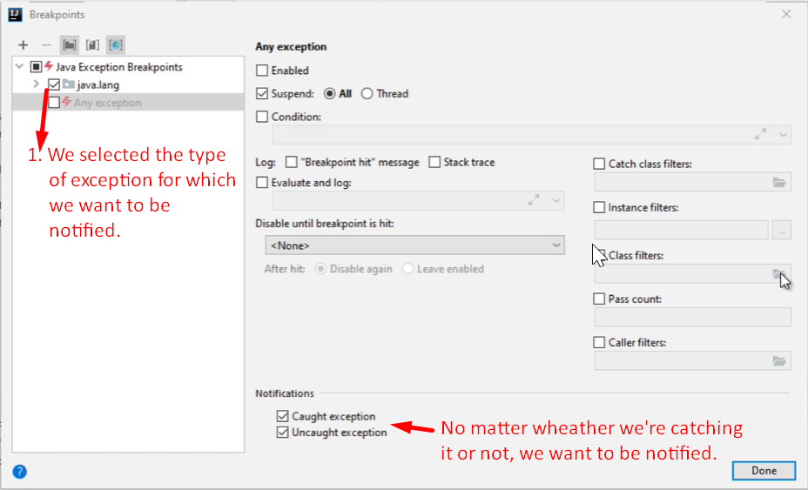
7. 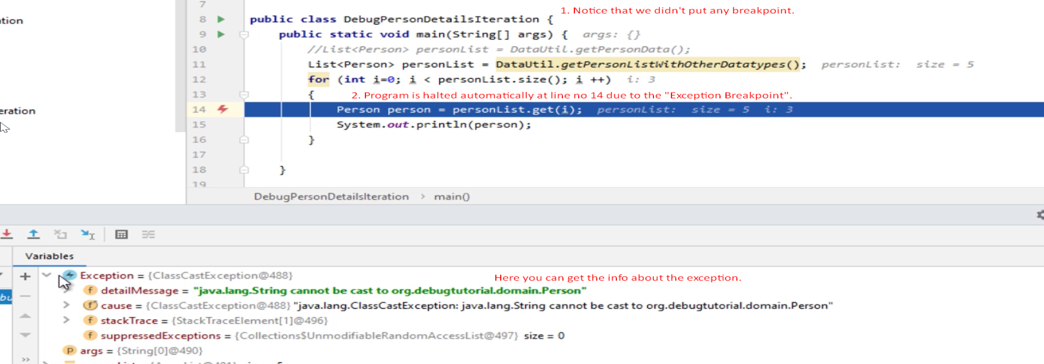
8. 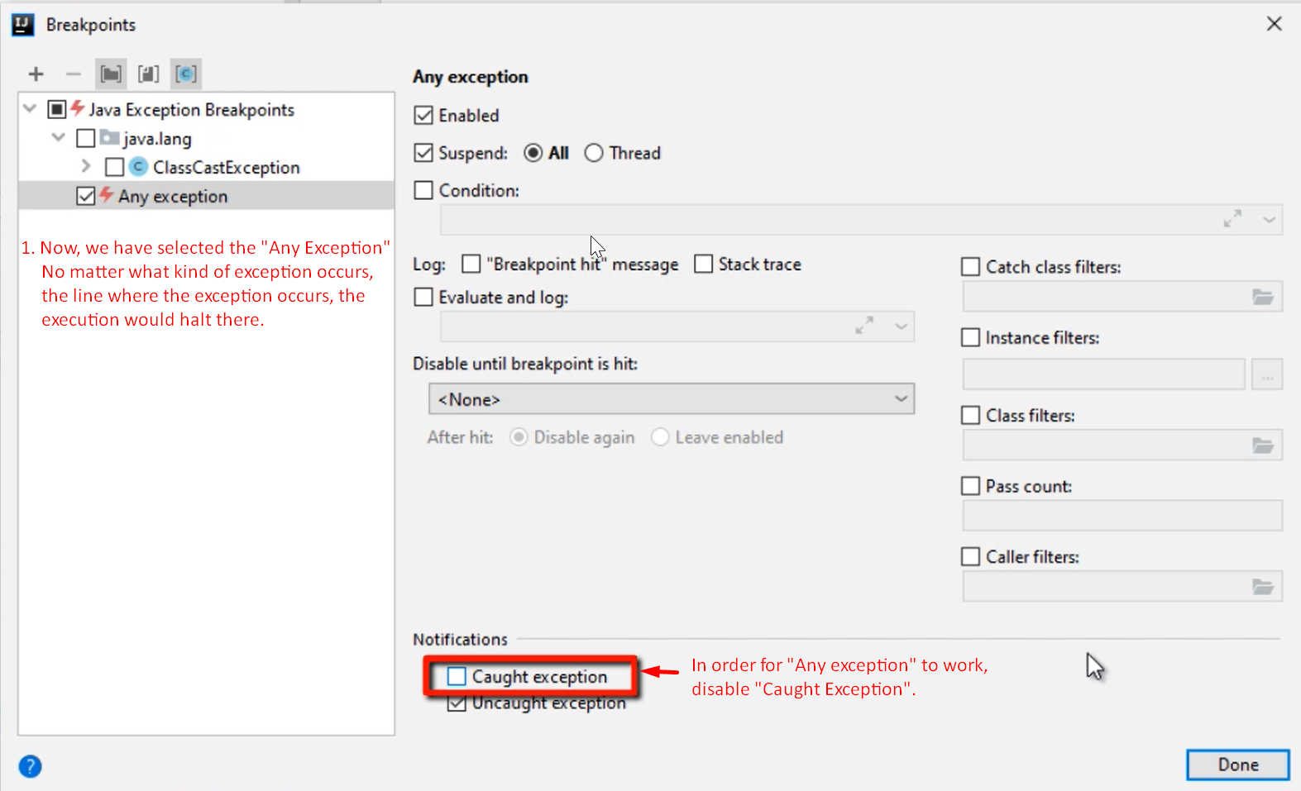
9. 